OPERATING SYSTEM

**Name:** Aditya Shimpi

**AI-DS Div C** Batch 2

**Roll no:** 26

**PRN no:** 12110021

**OS Lab Assignment No. 1 B] Basic Linux Command**

**Problems to be solved in the lab:**

1. Change your password to a password you would like to use for the remainder of the semester.passwd

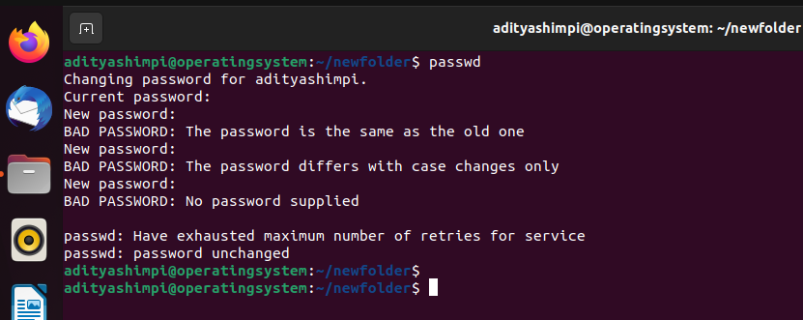

1. Display the system’s date.

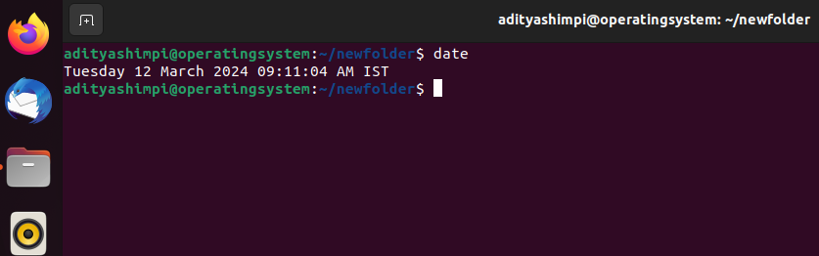

1. Count the number of lines in the /etc/passwd file.

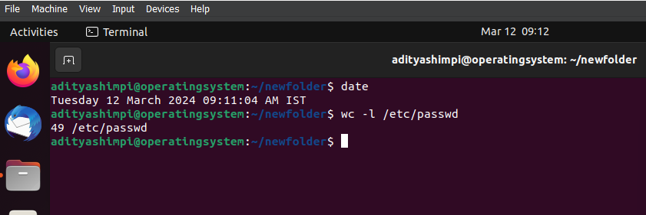

1. Find out who else is on the system.

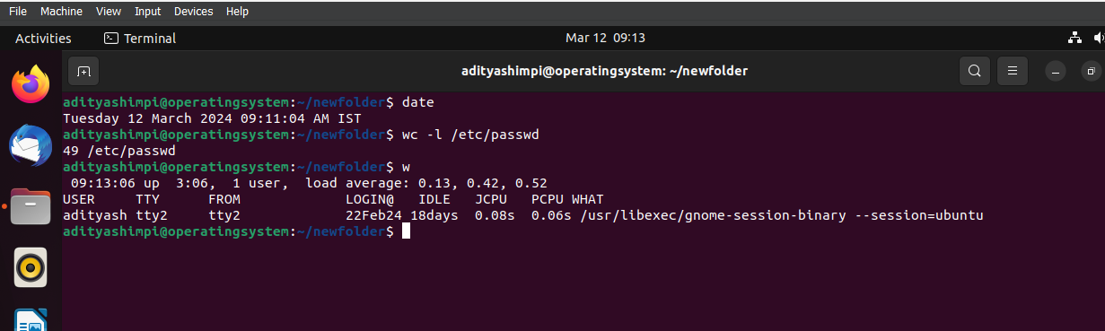

1. Direct the output of the man pages for the date command to a file named *mydate*.

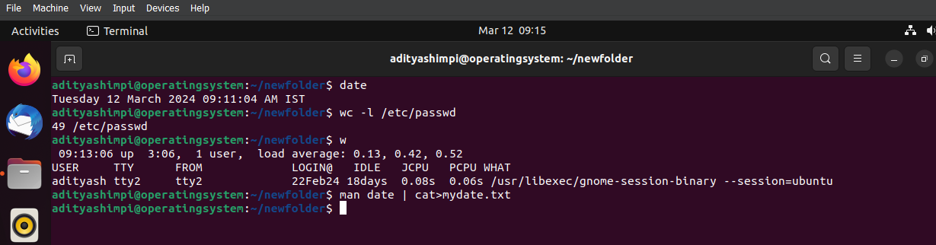

1. Create a subdirectory called *mydir*.

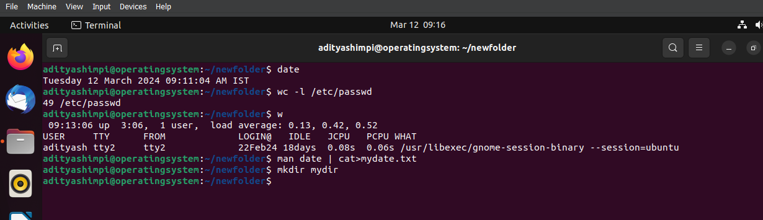

1. Move the file *mydate* into the new subdirectory.

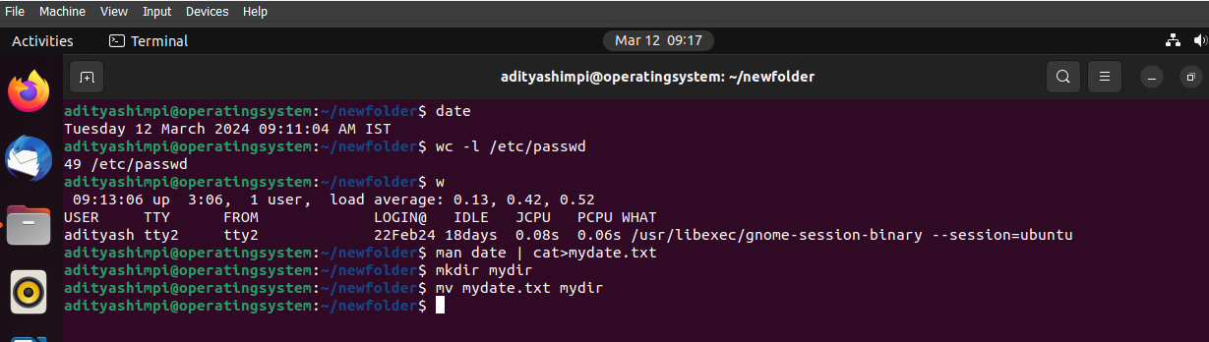

1. Go to the subdirectory *mydir* and copy the file *mydate* to a new file called *ourdate*

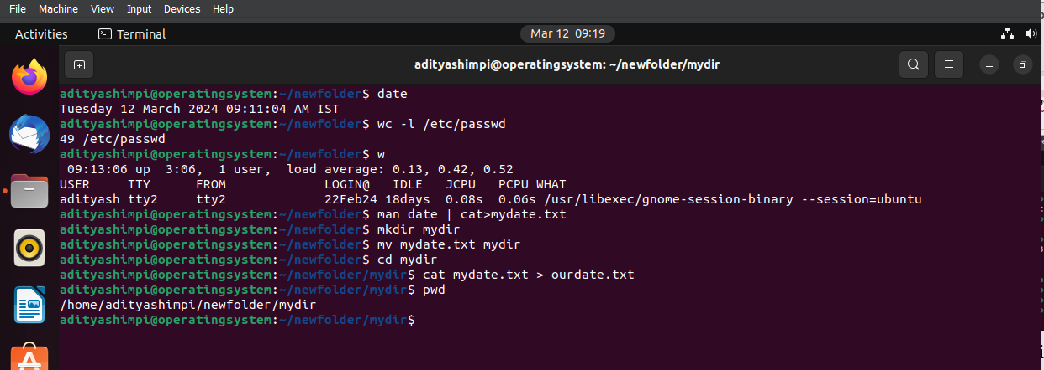

1. List the contents of *mydir*.

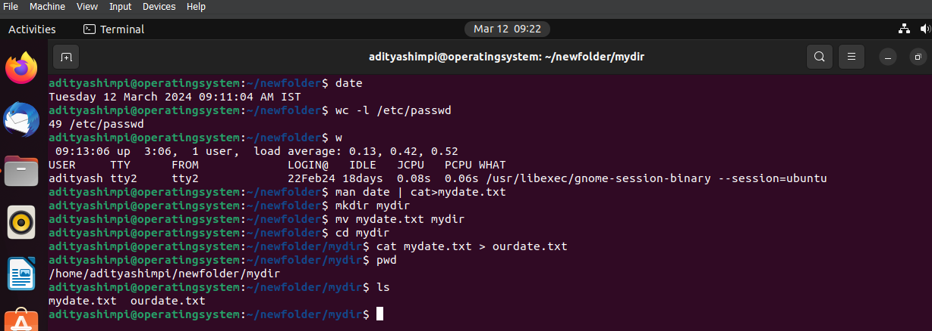

1. Do a long listing on the file *ourdate* and note the permission

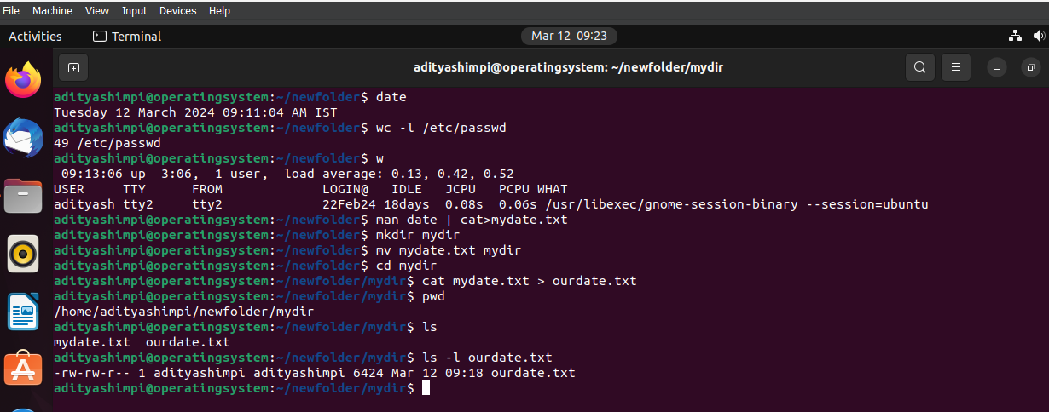

1. Display the name of the current directory starting from the root.

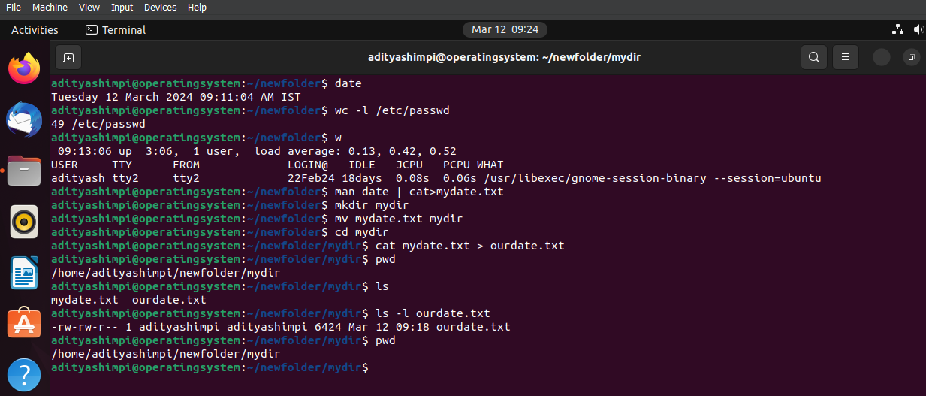

1. Move the files in the directory *mydir* to the another directory.

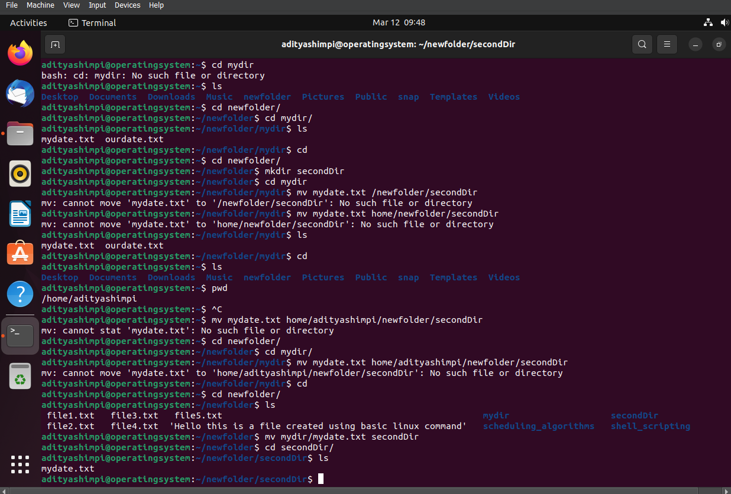

1. List all the files in your HOME directory.

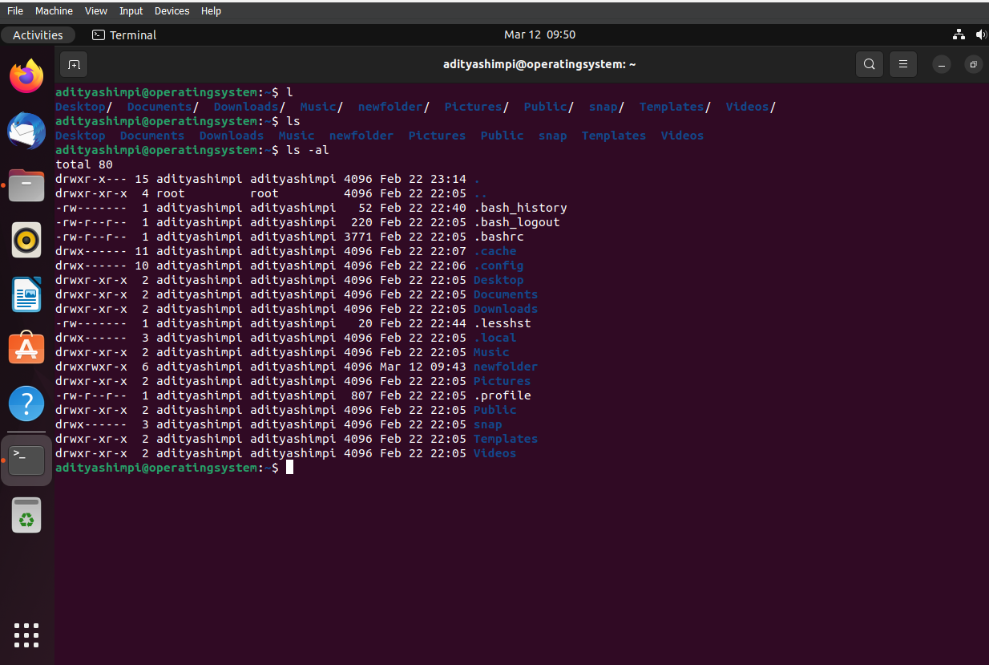

1. Display the first 5 lines of *mydate*.

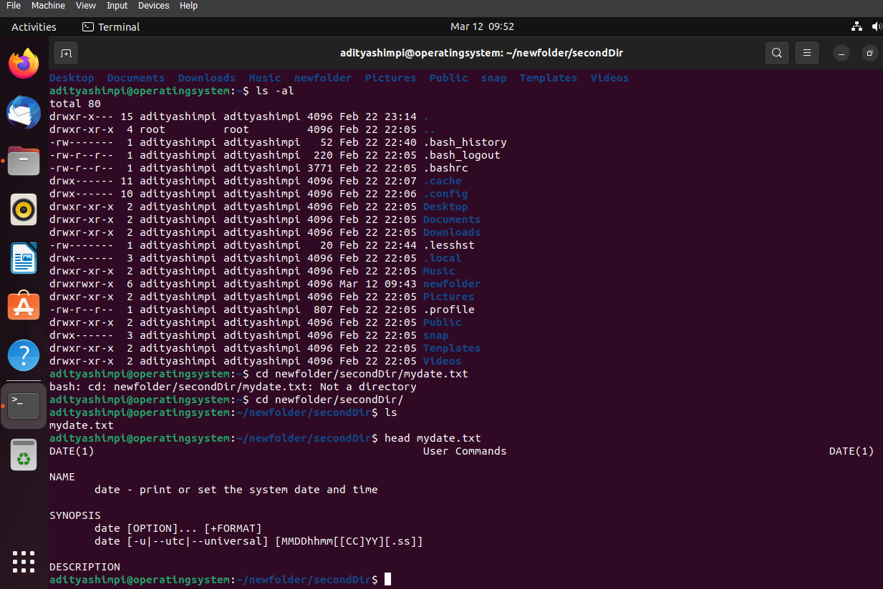

1. Display the last 8 lines of *mydate*.

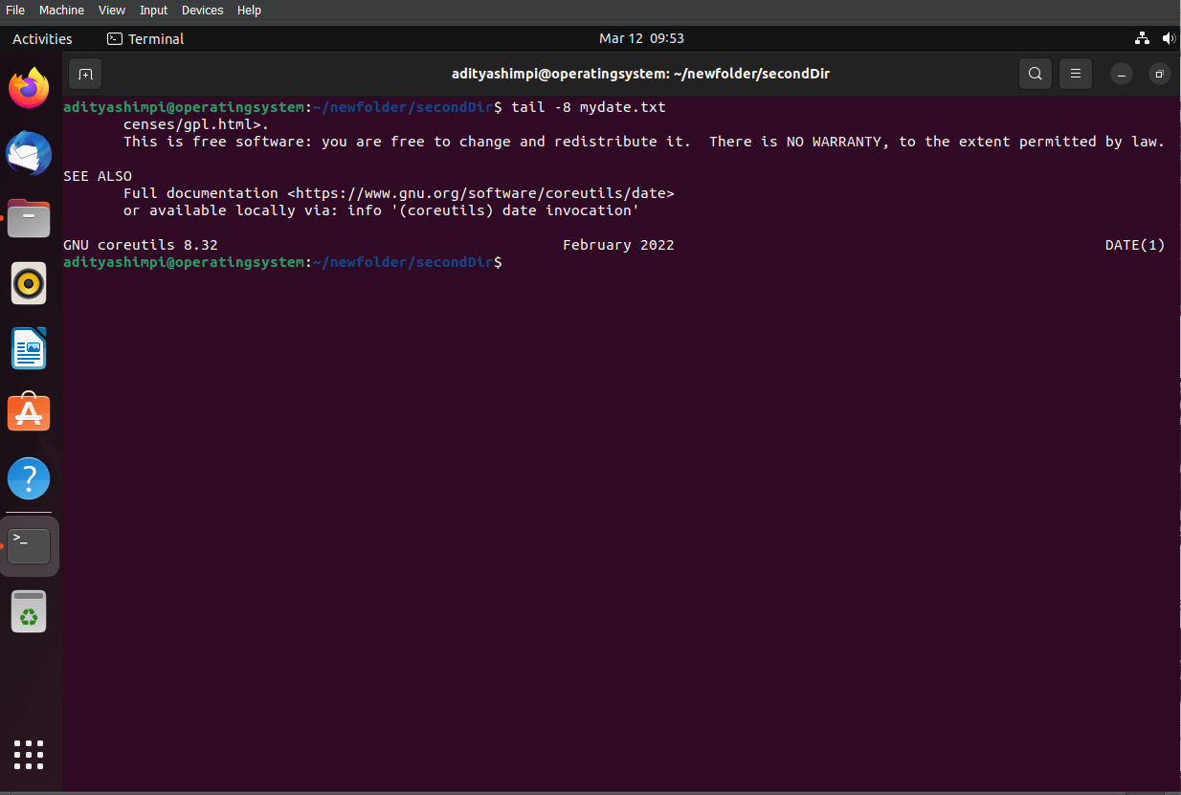

1. Remove the directory *mydir*.

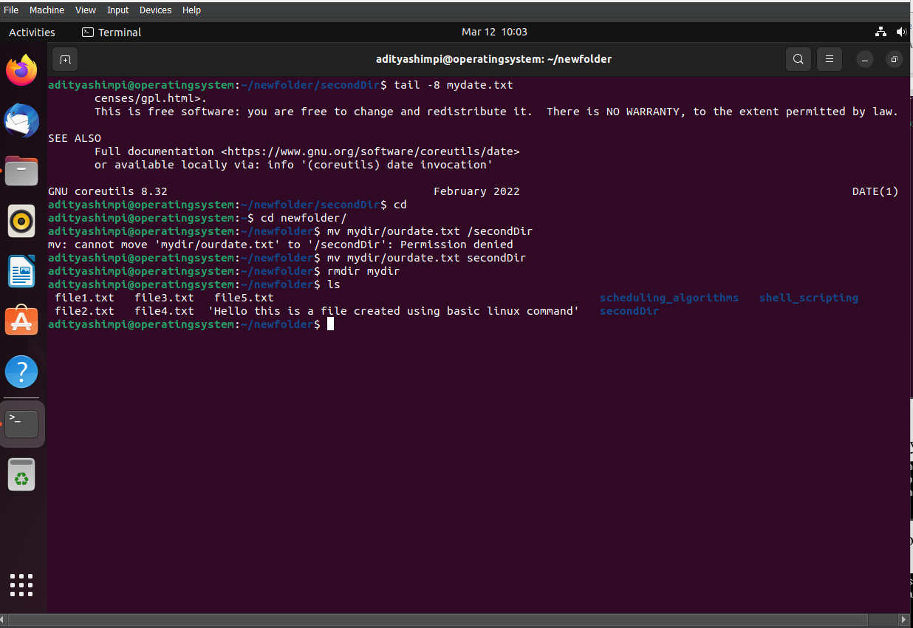

1. Redirect the output of the long listing of files to a file named *list*.

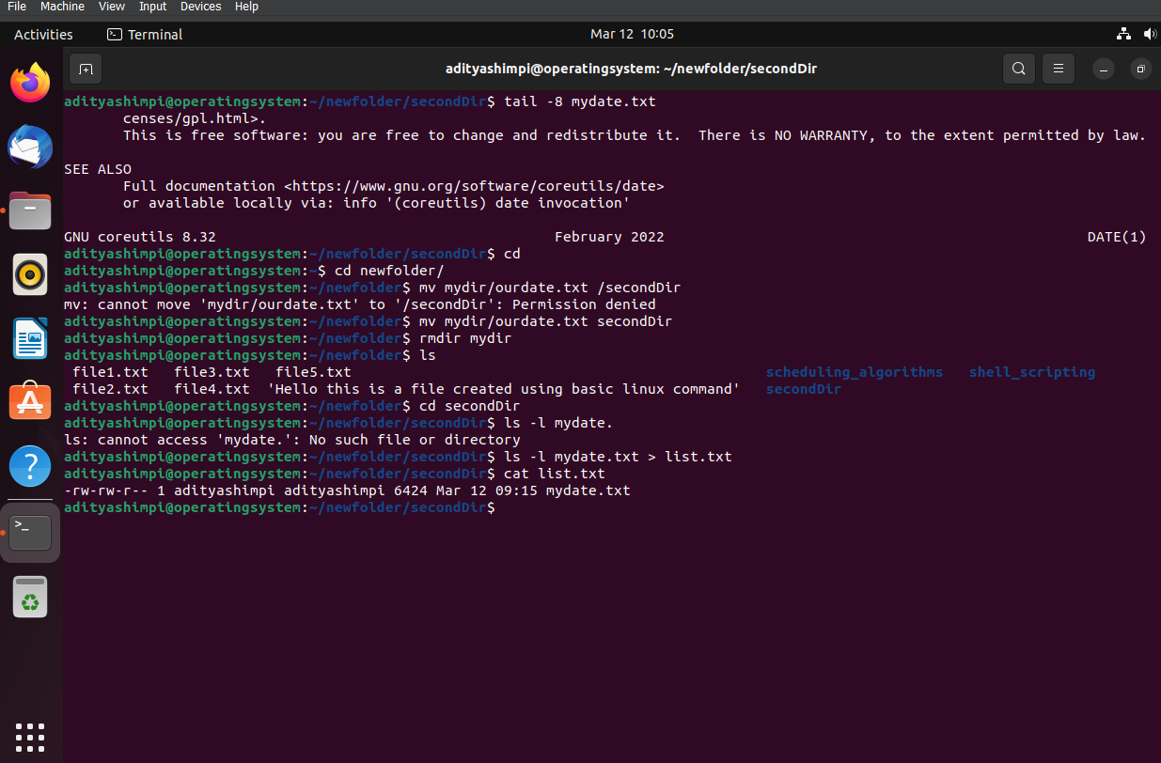

1. Select any 5 capitals of states in India and enter them in a file named capitals1. Choose 5 more capitals and enter them in a file named capitals2. Choose 5 more capitals and enter them in a file named capitals3. Concatenate all 3 files and redirect the output to a file named capitals

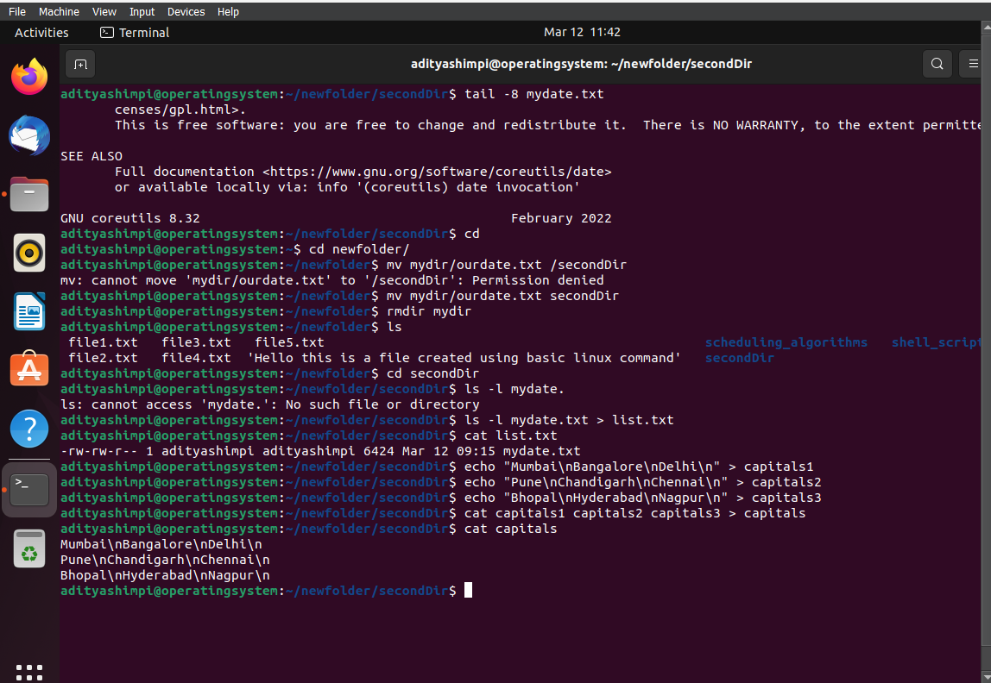

1. Concatenate the file capitals2 at the end of file capitals  
   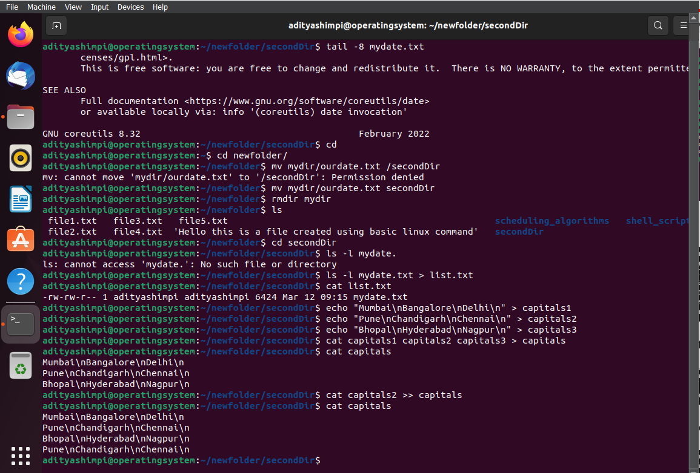
2. Redirect the file capitals as an input to the command “wc –l”.  
   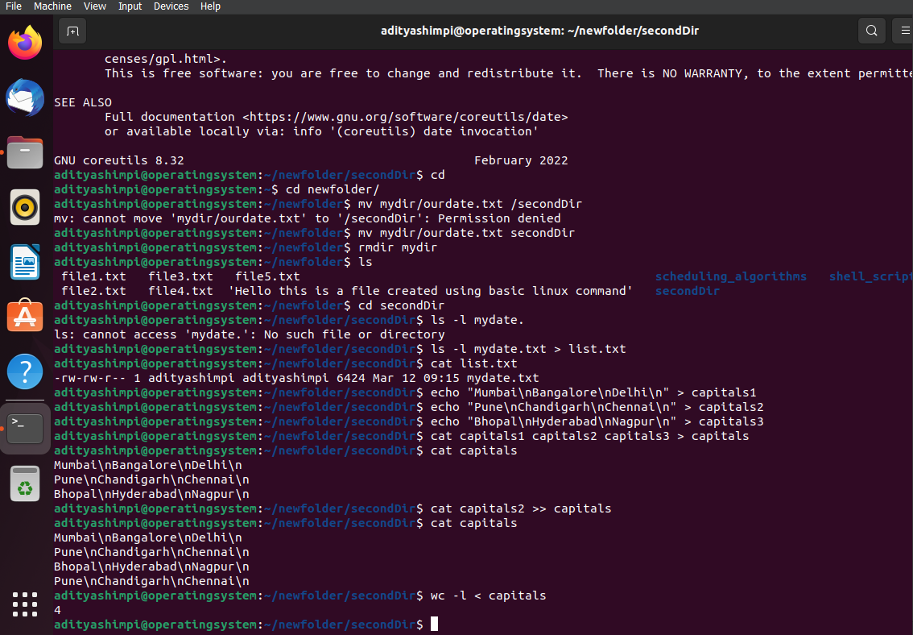
3. Give read and write permissions to all users for the file capitals.  
   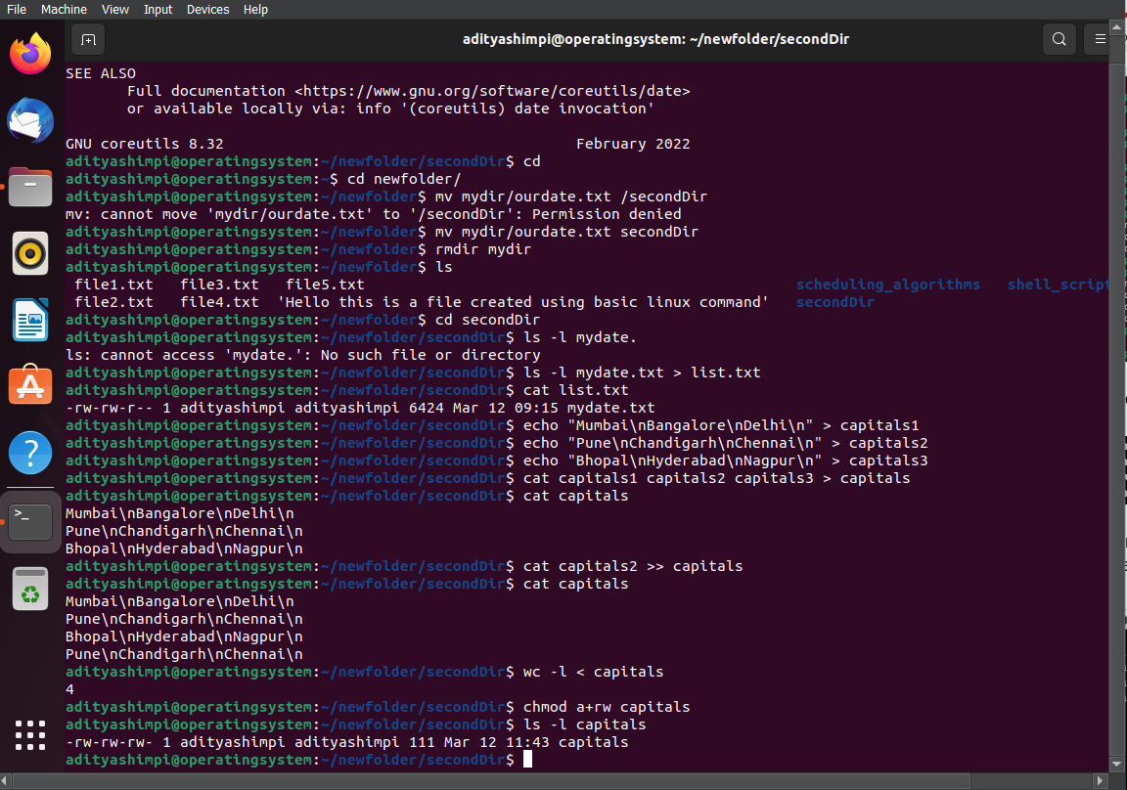
4. Give read permissions only to the owner of the file capitals. Open the file, make some changes and try to save it. What happens ?  
   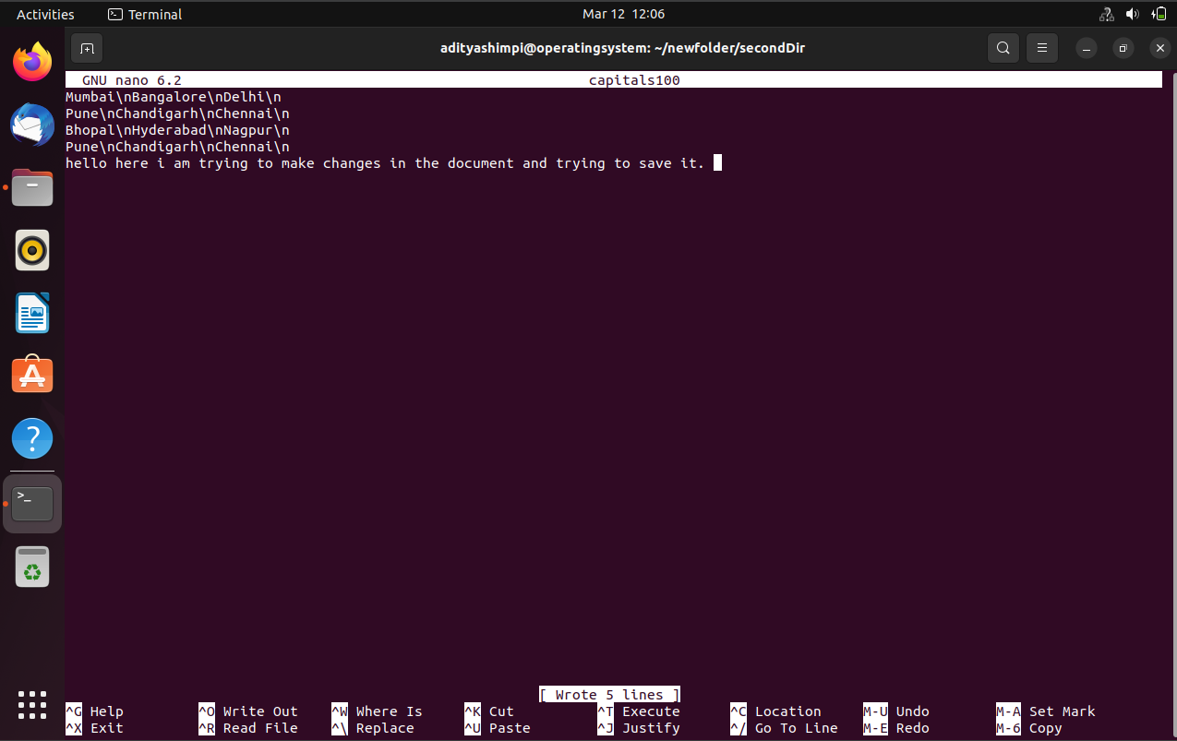  
     
     
   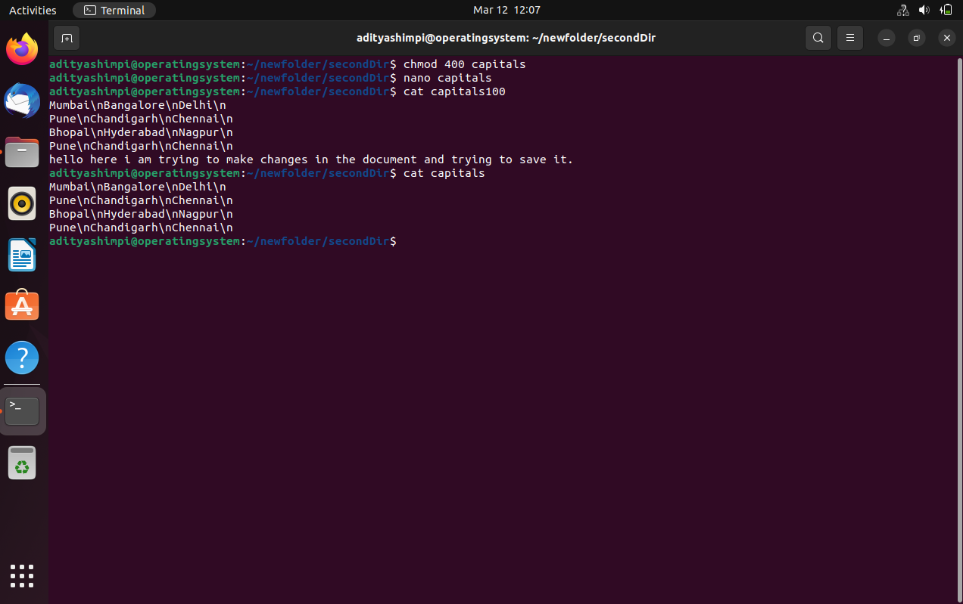
5. . Create an alias to concatenate the 3 files capitals1, capitals2, capitals3 and redirect the output to a file named capitals. Activate the alias and make it run.  
     
    alias

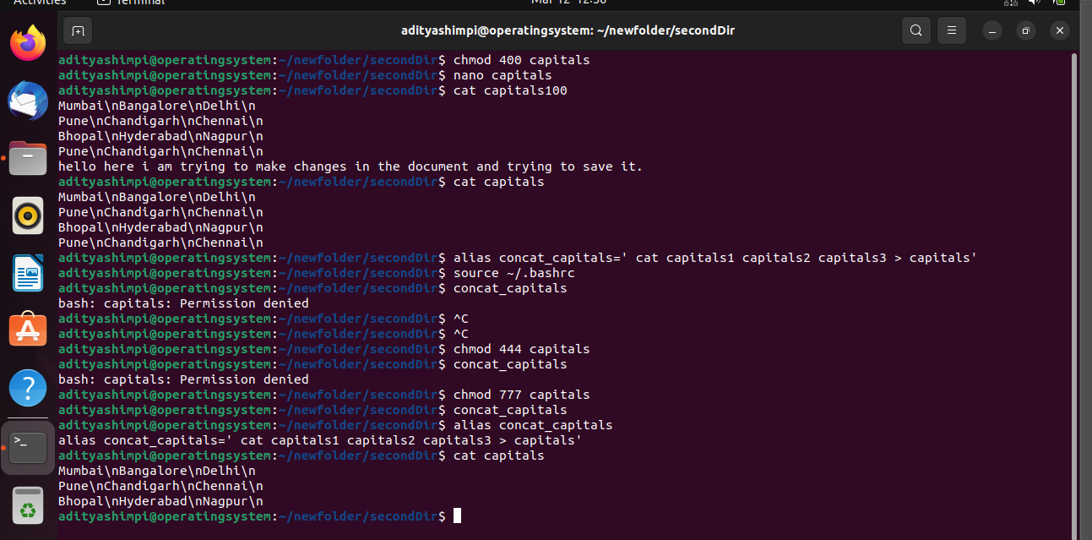

1. What are the environment variables PATH, HOME and TERM set to on your terminal ?  
   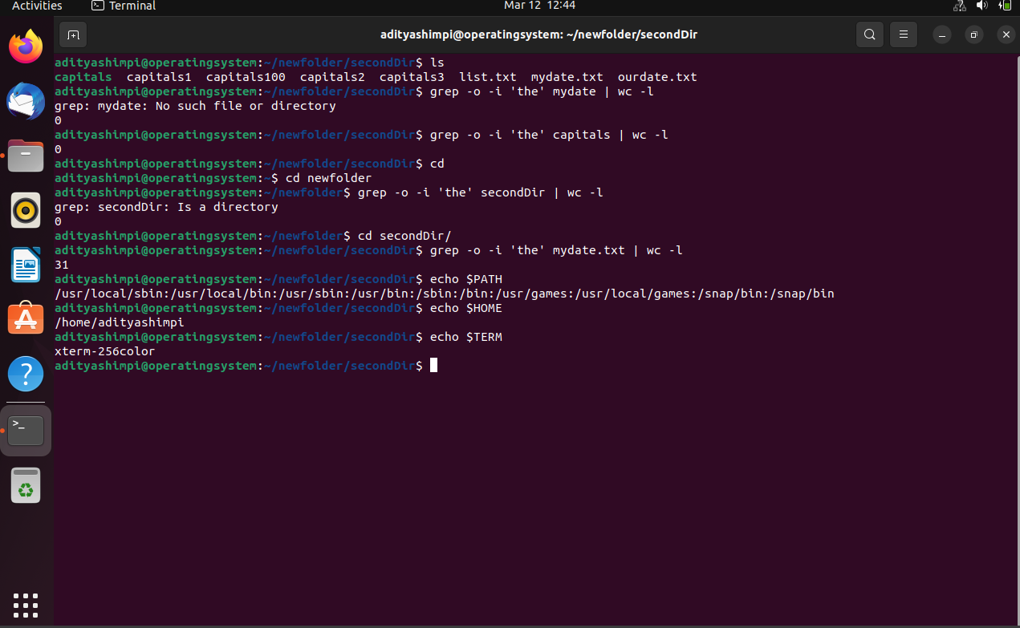
2. Find out the number of times the string “the” appears in the file mydate.  
     
   